**Exercise 1**

1. 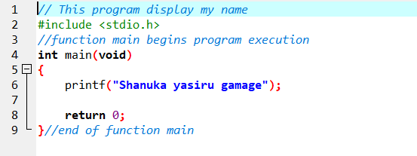
2. 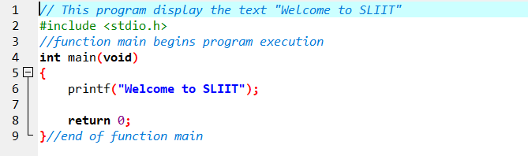

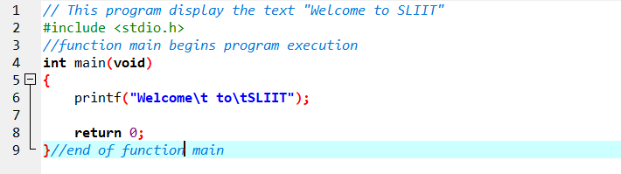

**Exercise 2**

start

Print “Hello World”

End



start

Input Length

Input Width

Perimeter = 2*Length + 2*Width

Area = Length * Width

Print Perimeter

Print Area

End

start



Input Sub 1 mark

Input Sub 2 mark

Avg_mark = (Sub 1 mark + Sub 2 mark)/2

Print Avg_mark

End

**Exercise 3**

1. Input = Celsius value

Calculation = (Celsius value * 9/5) + 32 = Fahrenheit value

Output = Fahrenheit value

1. Three buses A,B and C

Input = Fares A,B and C

Calculation = 5 * 14 * (fares A,B and C)

Output = traveling expenditure of the student for the entire semester.

1. Input = Employee salary

Calculation = salary * 20%

Output = Bonus